 | 7.3.16 Editors - 3D Viewport - Sidebar - Animation Tab
Table of content
Animation tab - Pose Library Panel 2
Create Pose Asset 2
Copy Pose as Asset 2
Active Asset Library 2
List of Asset Poses 2
Search Field 2
Invert 2
Sort by Name 2

Animation tab - Pose Library Panel
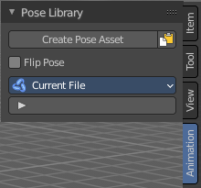
The Animation tab contains currently the pose library settings.

Create Pose Asset
This button becomes active with a armature in pose mode. It allows you to insert the current pose into the Asset browser, to reuse it at a later point.

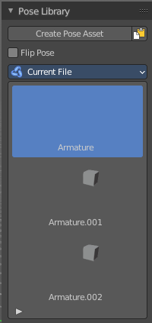
Copy Pose as Asset
Copy the current pose as an asset, which can then be pasted into an asset library.

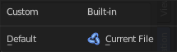
Active Asset Library
Which asset library to use. A custom one, or the built in asset lib. Default is the built-in called Current File.

List of Asset Poses
The list of available asset poses.

Search Field

You can expand a search field at the bottom of the list. Type in your term and hit enter to filter for your term.

Invert
Exclude the search term instead of searching for it.

Sort by Name
Sort the List by name.

